**e-TrustEx**

*Demo Framework*

**Document history**

|  |  |  |  |
| --- | --- | --- | --- |
| Version | Date | Comment | Modified pages |
| 1.00 | 30/09/2012 | Creation for e-TrustEx v1.0.0 | All pages |
|  |  |  |  |
|  |  |  |  |
|  |  |  |  |

CONTENTS

1. Overview 3

2. Test Cases 3

2.1. Instructions e-TrustEx 3

2.2. Instructions SoapUI 3

# Overview

The e-TrustEx demo framework consists of test cases to assist the user in running test cases for the e-TrustEx platform.

# Test Cases

The test cases in this demo suit are bundled as a SoapUI project that the user can execute after installing and configuring the e-TrustEx platform.

## Instructions e-TrustEx

Install the e-TrustEx platform either on a local machine or a test server as detailed in the instruction manual.

Ensure that all the database configuration scripts are executed, including the scripts to configure the demo user details.

## Instructions SoapUI

### Installation

SoapUI is an open source test tool for web-service testing. A free version without restrictions is available and this free version is sufficient to run the projects in this package.

Download SoapUI free via <http://www.soapui.org/> and follow the installation instruction on the website.

The demo suite contains a script to clean the test messages from the e-TrustEx database. Since this script requires a database connection to be created from a groovy script, the proper database driver needs to be installed. To install the MySQL Connector/J, go to <http://dev.mysql.com/downloads/connector/j/> and choose the proper version. Extract the .jar file to the SoapUI "lib" installation folder and restart your SoapUI instance before running the tests.

### Configuration

Inside SoapUI, create a new workspace (File->New Workspace) and load the demo project in this package (File->Import Project).

The project is based on the user details as defined in the database configuration script. If another username/password is required, it can be configured in the Request Properties of each service request (and the database scripts that delete the test messages will need updates as well).

The project is based on the e-TrustEx platform to be installed on the localhost. If another server is used, update the WSDL URLs and service endpoints of the demo suite before executing the tests.

### Executing the demo suite

Inside the e-TrustEx project, a separate test suite is created for each service to test the basic flow of that service. This test suite contains a test case that automatically calls the required service endpoints and checks the resulting response.

A description of the steps in a test case is shown when the mouse pointer is pointed at the test case or by opening a test case and clicking the description tab.

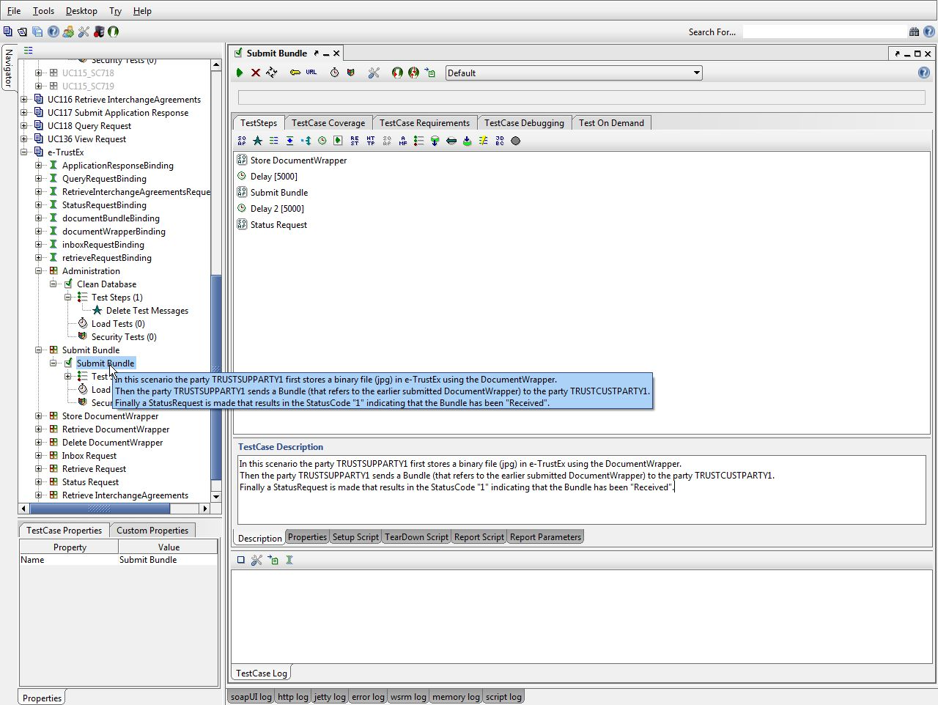

Figure 1 - Test description

To run the test case for a specific service, press the green play/send button to execute all test steps and see the results.

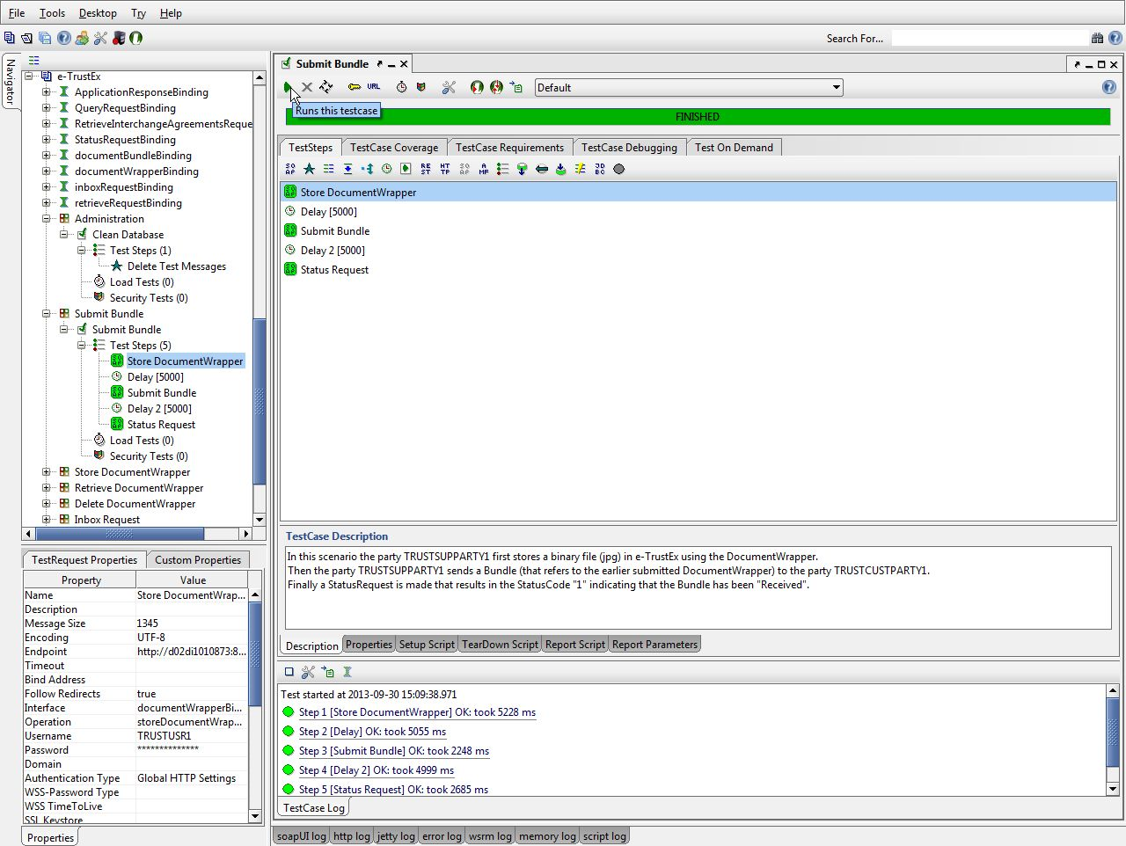

Figure 2 - Running a test case

The details of the requests and responses can be seen by opening a test step.

The request is shown on the left window and the response is shown in the right window.

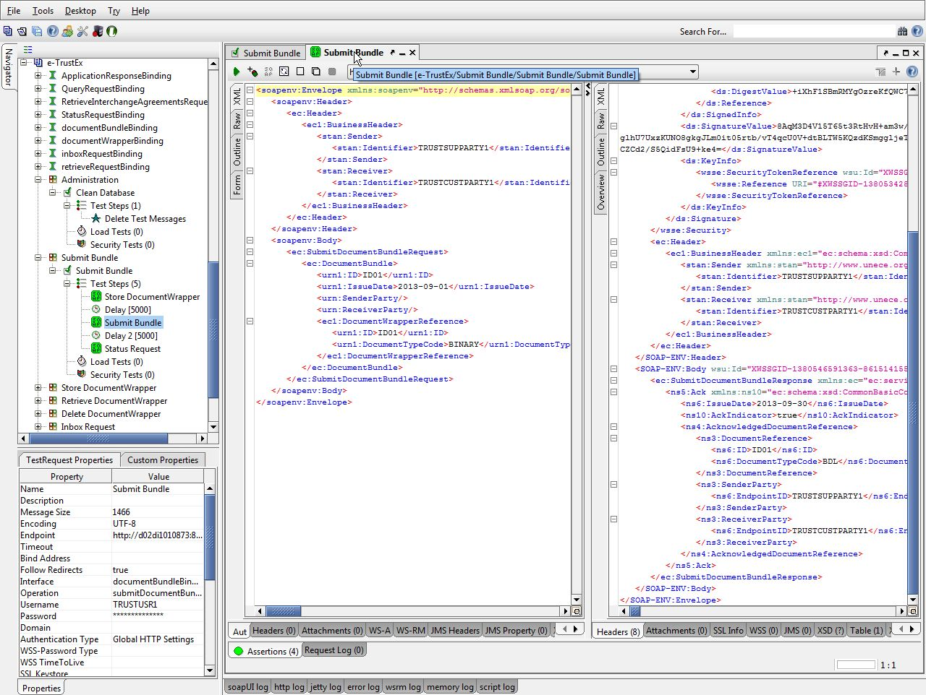

Figure 3 - Test request and response

Each test request contains several assertions that perform specific checks on the response of web-service request. To see the details, click the Assertions tab in the bottom of the screen.

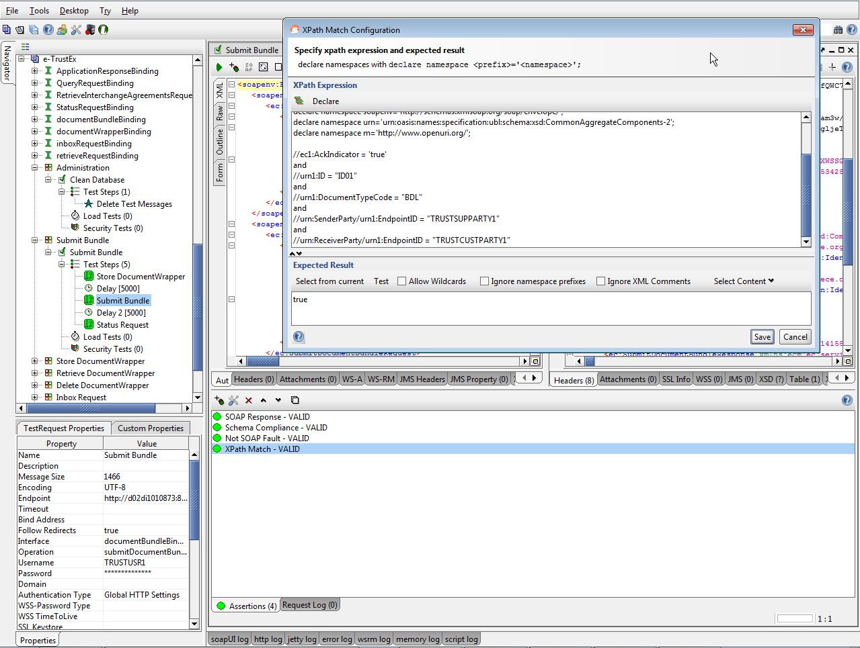

Figure 4 - Test assertions

Each test case can be run independently from the other test cases. However, before running a specific test case for the second time, the "Clean Database" script in the "Administration" test suite should be executed. If this action is not done, then some test steps will fail since the system does not allow the same combination of ID and document type to be sent twice by the same user.